INCUMBENCY STATEMENT OF OFFICER M.C JARANWALA
- Administrator, M.C Jaranwala

Name of Officer | Date of Joining | 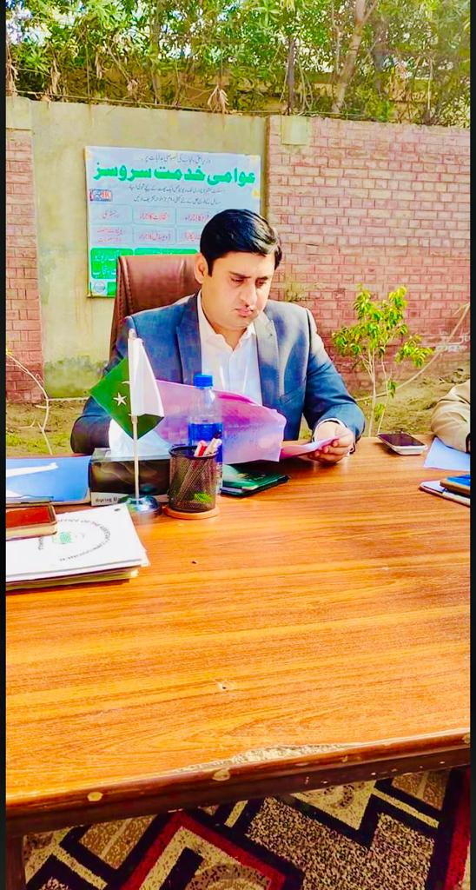
Ahmad Saeed <anj | 02-01-2022

- Chief Officer, M.C Jaranwala

Name of Chief Officer | Date of Joining
Mian Ashfaq (BS-17/LGS)

- Municipal Officer (Finance), M.C Jaranwala

Name of Officer | Date of Joining | 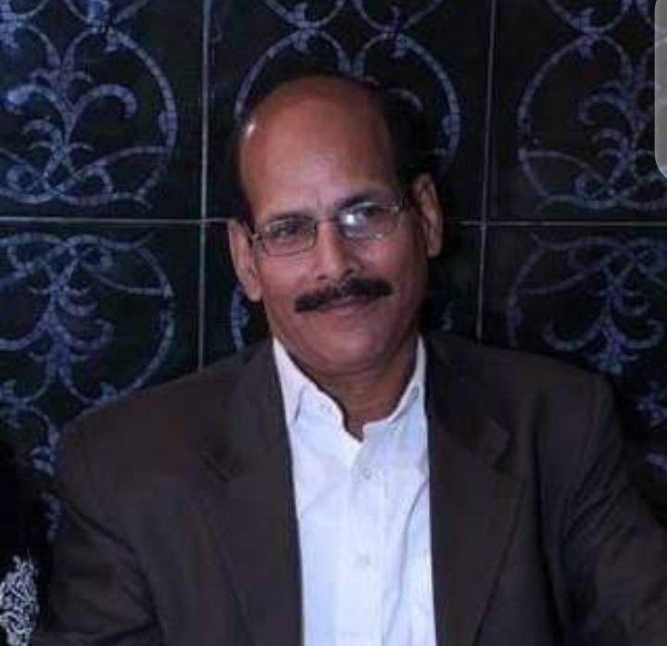
Zia Ul hassan (BS-17/LGS)

- Municipal Officer (Regulation), M.C Jaranwala

Name of Officer | Date of Joining
Mian Ashfaq (BS-17/LGS)

- Municipal Officer (Planning), M.C Jaranwala

Name of Officer | Date of Joining | 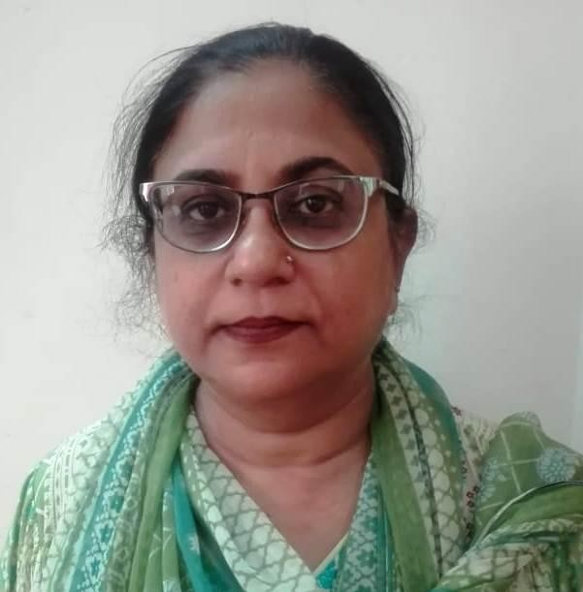
Shareen Newton (BS-17/LGS)

- Municipal Officer (Infrastructure), M.C Jaranwala

Name of Officer | Date of Joining
Sadam Hussain (BS-17/PHED)

